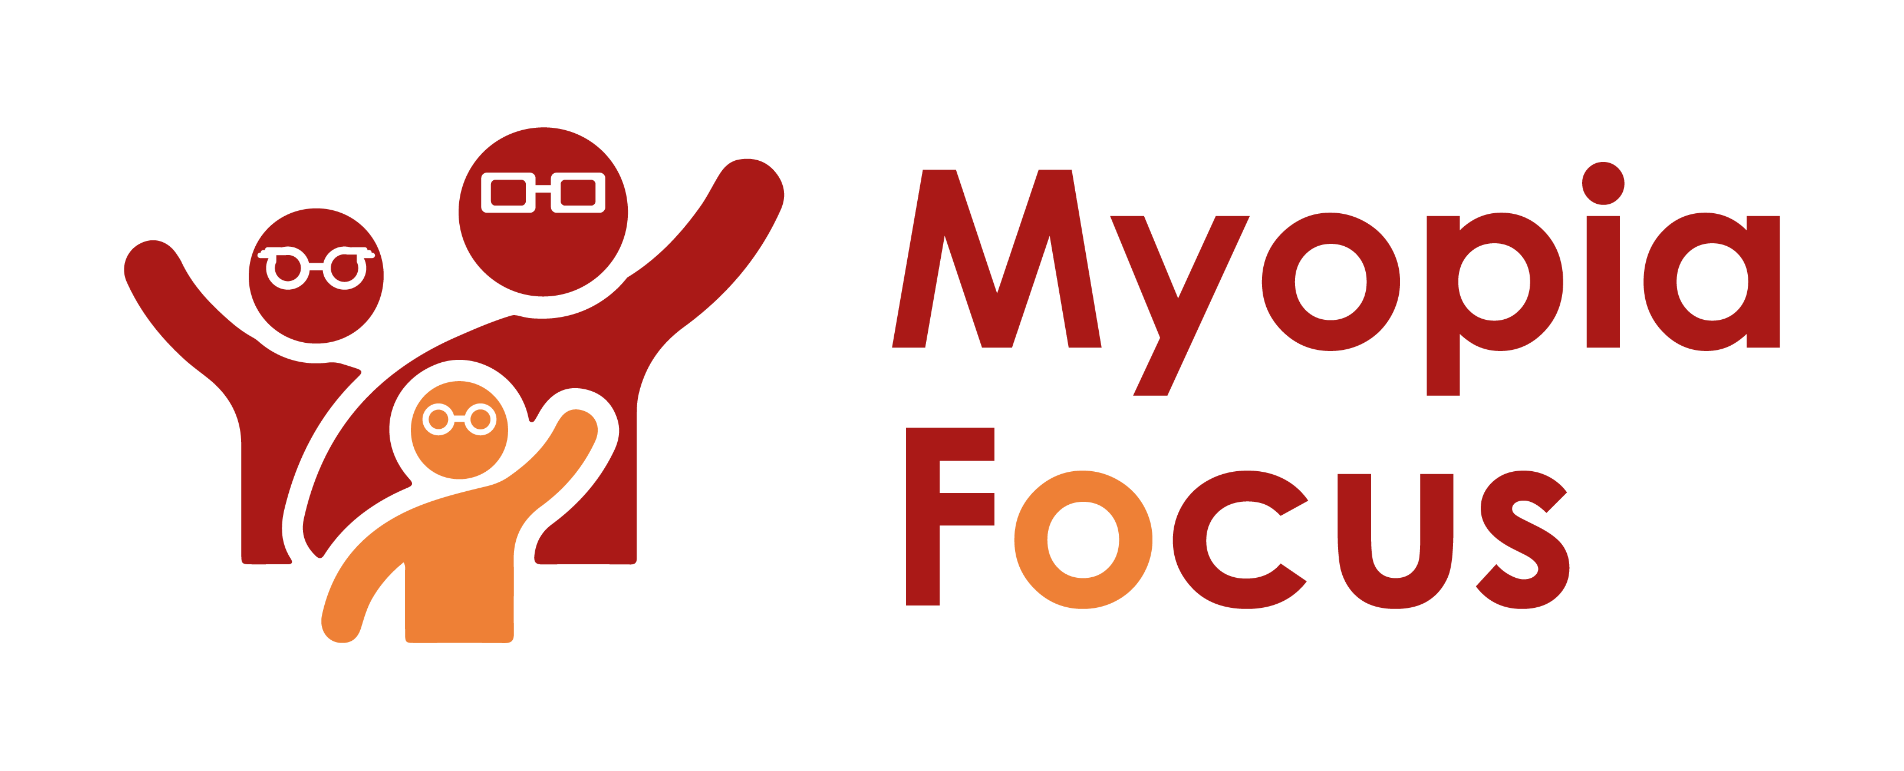
info@myopiafocus.org
0118 350 0800
www.myopiafocus.org
The Blade, Abbey Square,
Reading, RG1 3BE

Please note.
Thank you for downloading our article. Please feel free to add comments or make amendments to suit your needs before publishing it on your relevant platforms. However, as Myopia Focus is a non-profit organisation, we kindly request that you include a direct link to Myopia Focus within the article. This helps us spread awareness and ensure easy access to our resources. We appreciate your support and collaboration in promoting our mission.

Understanding the Implications of Blurry Vision in Children

Children's vision can sometimes become blurry, indicating a possible development of myopia, commonly known as short-sightedness. Often, myopia progresses gradually, and children may adapt to the changes without realizing anything is amiss. It is only when they start complaining about difficulty seeing the whiteboard at school or sitting closer to the TV at home that parents begin to take notice and ask questions.

Myopia occurs due to the light focusing before it reaches the retina inside the eye. Another condition that may accompany myopia is astigmatism, where the cornea's front part is not perfectly spherical. This irregularity causes light to scatter, resulting in either short-sightedness or long-sightedness or sometimes a combination of both.

Fortunately, in most cases, corrective lenses or spectacles can significantly improve vision affected by myopia and astigmatism. Additionally, encouraging lifestyle changes, such as spending more time outdoors, may help slow down the progression of myopia over time.
It's essential to pay attention to any changes in your child's vision and promptly address any concerns with a qualified member of our team to ensure their eye health and visual acuity are appropriately managed.

[Name of Business] is proud to support Myopia Focus

Independent information on myopia and myopia management can be found on myopiafocus.org.

Please also consider signing this change.org petition to get the NHS to recognise myopia as an ocular disease and improve funding for myopia management for children.

Images:
Please feel free to use the below image:

