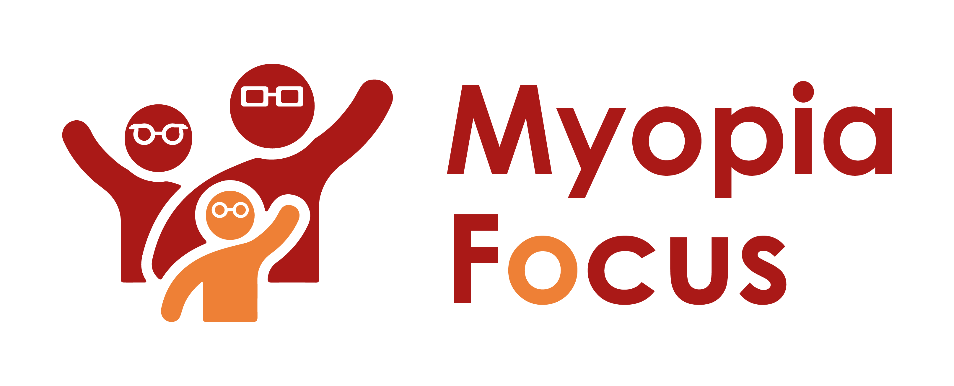
info@myopiafocus.org
0118 350 0800
www.myopiafocus.org
The Blade, Abbey Square,
Reading, RG1 3BE

Please note.
Thank you for downloading our article. Please feel free to add comments or make amendments to suit your needs before publishing it on your relevant platforms. However, as Myopia Focus is a non-profit organisation, we kindly request that you include a direct link to Myopia Focus within the article. This helps us spread awareness and ensure easy access to our resources. We appreciate your support and collaboration in promoting our mission.

Is there a Time Limit for Myopia Management

Managing myopia is a critical consideration once your child has been diagnosed with this condition. While it is important to recognize that myopia is mostly irreversible, simply accepting a lifetime of wearing glasses should not be the only approach. Since myopia tends to progress over time, anything that can slow down its advancement can be beneficial in the long run. Although early treatment is preferable, even older children whose myopia has advanced can benefit from a myopia management plan.

A six-year study investigated the effects of using dual focus contact lenses for myopia management [1]. These lenses not only correct vision but also help control the way light falls on the retina, addressing some of the factors contributing to myopia. The study confirmed previous findings, showing that treating myopic children with dual focus lenses resulted in a sustained reduction in myopia progression over the six-year period. Interestingly, it also revealed that children who switched from single vision lenses to dual lenses after three years experienced "significant slowing" of myopia progression. This demonstrates that even in older children, implementing myopia management plans can yield benefits.

In conclusion, while myopia is mostly irreversible, managing its progression through strategies like dual focus lenses can provide cumulative advantages in the future. Early intervention is ideal, but even in older children, myopia management can be effective in slowing down its advancement.

[Name of Business] is proud to support Myopia Focus

Independent information on myopia and myopia management can be found on myopiafocus.org.

Please also consider signing this change.org petition to get the NHS to recognise myopia as an ocular disease and improve funding for myopia management for children.

Images:
Please feel free to use the below image:

