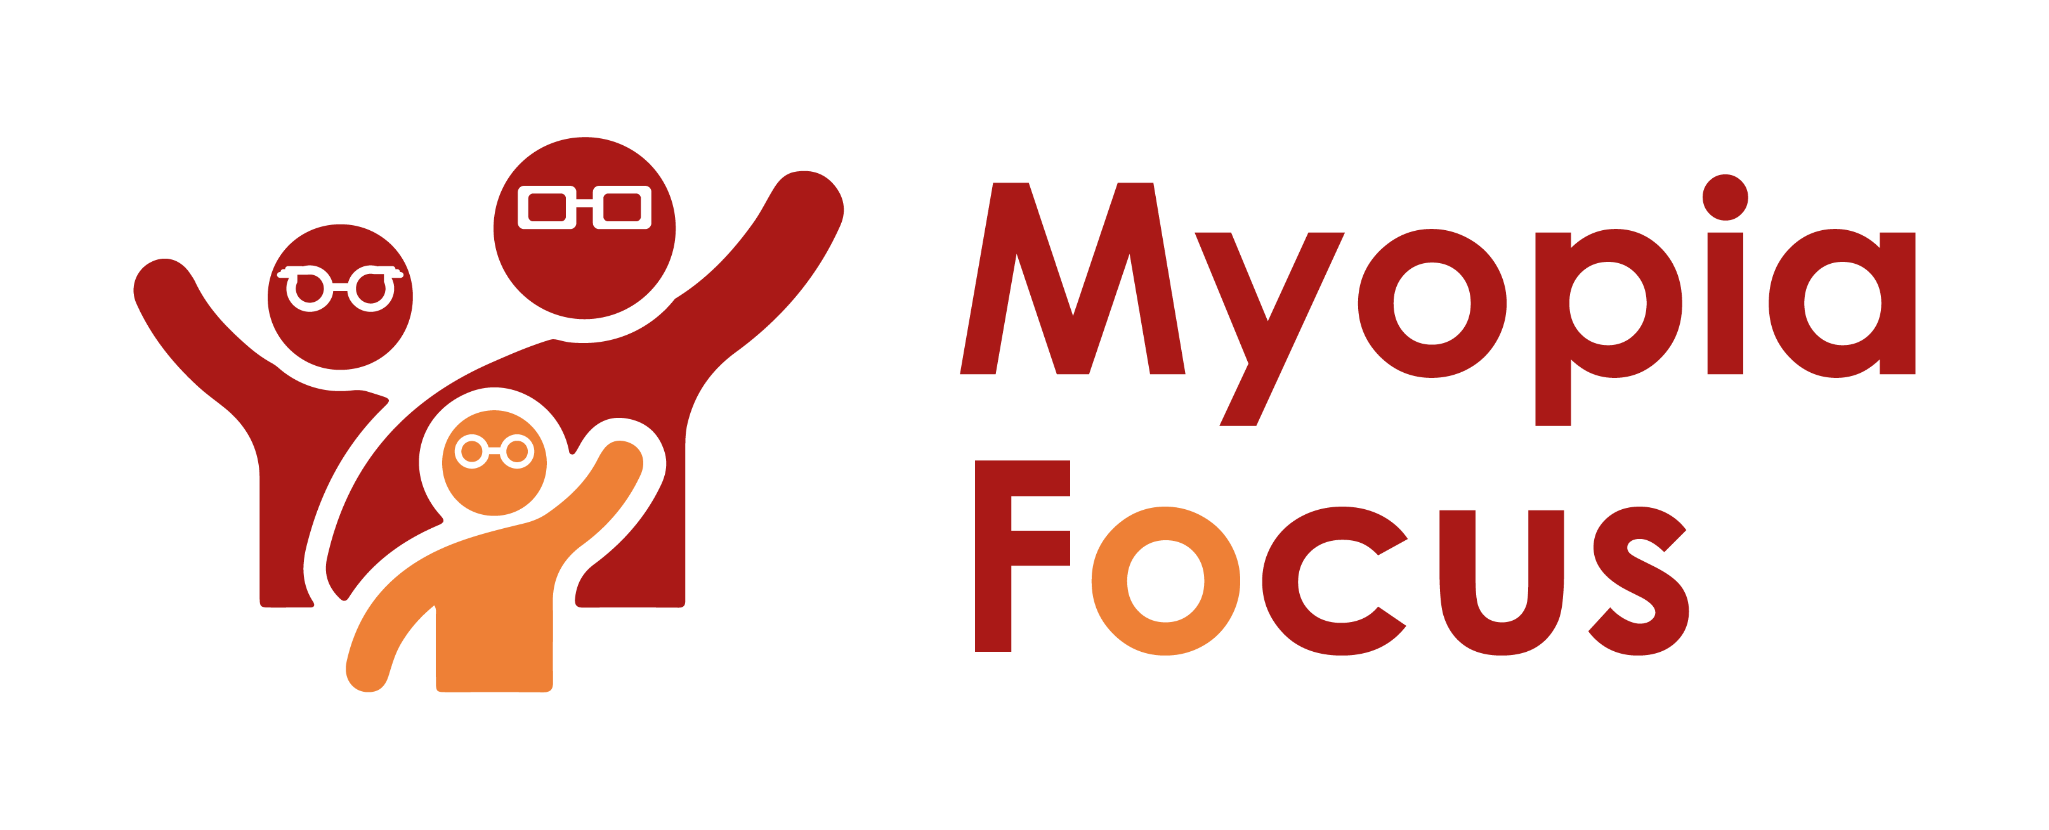
info@myopiafocus.org
0118 350 0800
www.myopiafocus.org
The Blade, Abbey Square,
Reading, RG1 3BE

Please note.
Thank you for downloading our article. Please feel free to add comments or make amendments to suit your needs before publishing it on your relevant platforms. However, as Myopia Focus is a non-profit organisation, we kindly request that you include a direct link to Myopia Focus within the article. This helps us spread awareness and ensure easy access to our resources. We appreciate your support and collaboration in promoting our mission.

My Child's Myopia and the Role of Glasses in Managing it
As a concerned parent, the possibility of your child needing glasses due to myopia can be worrisome. Questions may arise about the causes of the condition and its potential impact on your child's development and future career choices. Additionally, you might have heard the urban myth that early use of glasses could worsen eyesight. While there is a grain of truth in this, it's essential to understand the facts.

A 2002 study [1] revealed that if glasses are too weak to fully correct myopia, they could potentially accelerate its progression. It highlights the importance of regular eye tests and ensuring that the prescribed glasses are accurate to avoid any harm. The study also found that uncorrected blurred vision at any distance could stimulate the progression of myopia, while a full-distance correction does not. Thus, wearing correctly-prescribed glasses is vital, as it not only helps slow down myopia deterioration but also prevents adverse effects on your child's development.

Several subsequent studies, including a 2020 cross-study review published in the Journal of Optometry [2], have corroborated these findings, emphasizing the benefits of wearing glasses. A 2012 Stanford Rural Education Action Program report [3] confidently concluded that wearing glasses does not harm students' eyes and can significantly reduce the severity of visual acuity decline.

It's crucial to debunk the myth that wearing glasses worsens myopia. On the contrary, appropriately prescribed glasses can be beneficial. However, certain lifestyle factors may accelerate the progression of myopia. The prevalence of myopia has increased significantly in recent times, partly attributed to excessive screen time and decreased outdoor activities.

Studies have shown that excessive screen use, particularly at close distances, can contribute to myopia development. The pandemic-induced online schooling further exacerbated this issue, leading to a significant increase in myopia cases among young children. Spending more time outdoors during childhood has been linked to a lower risk of developing myopia and may delay its progression [4].

To effectively manage myopia, it is crucial to address both vision correction through glasses and lifestyle factors. Encouraging outdoor activities and reducing screen time can positively impact myopia progression.

In conclusion, wearing properly prescribed glasses will not worsen your child's myopia; rather, it can be beneficial in managing the condition. However, lifestyle changes, such as reducing screen time and increasing outdoor activities, are also essential in combating the rising prevalence of myopia among children.

[Name of Business] is proud to support Myopia Focus

Independent information on myopia and myopia management can be found on myopiafocus.org.

Please also consider signing this change.org petition to get the NHS to recognise myopia as an ocular disease and improve funding for myopia management for children.

Images:
Please feel free to use the below image:

