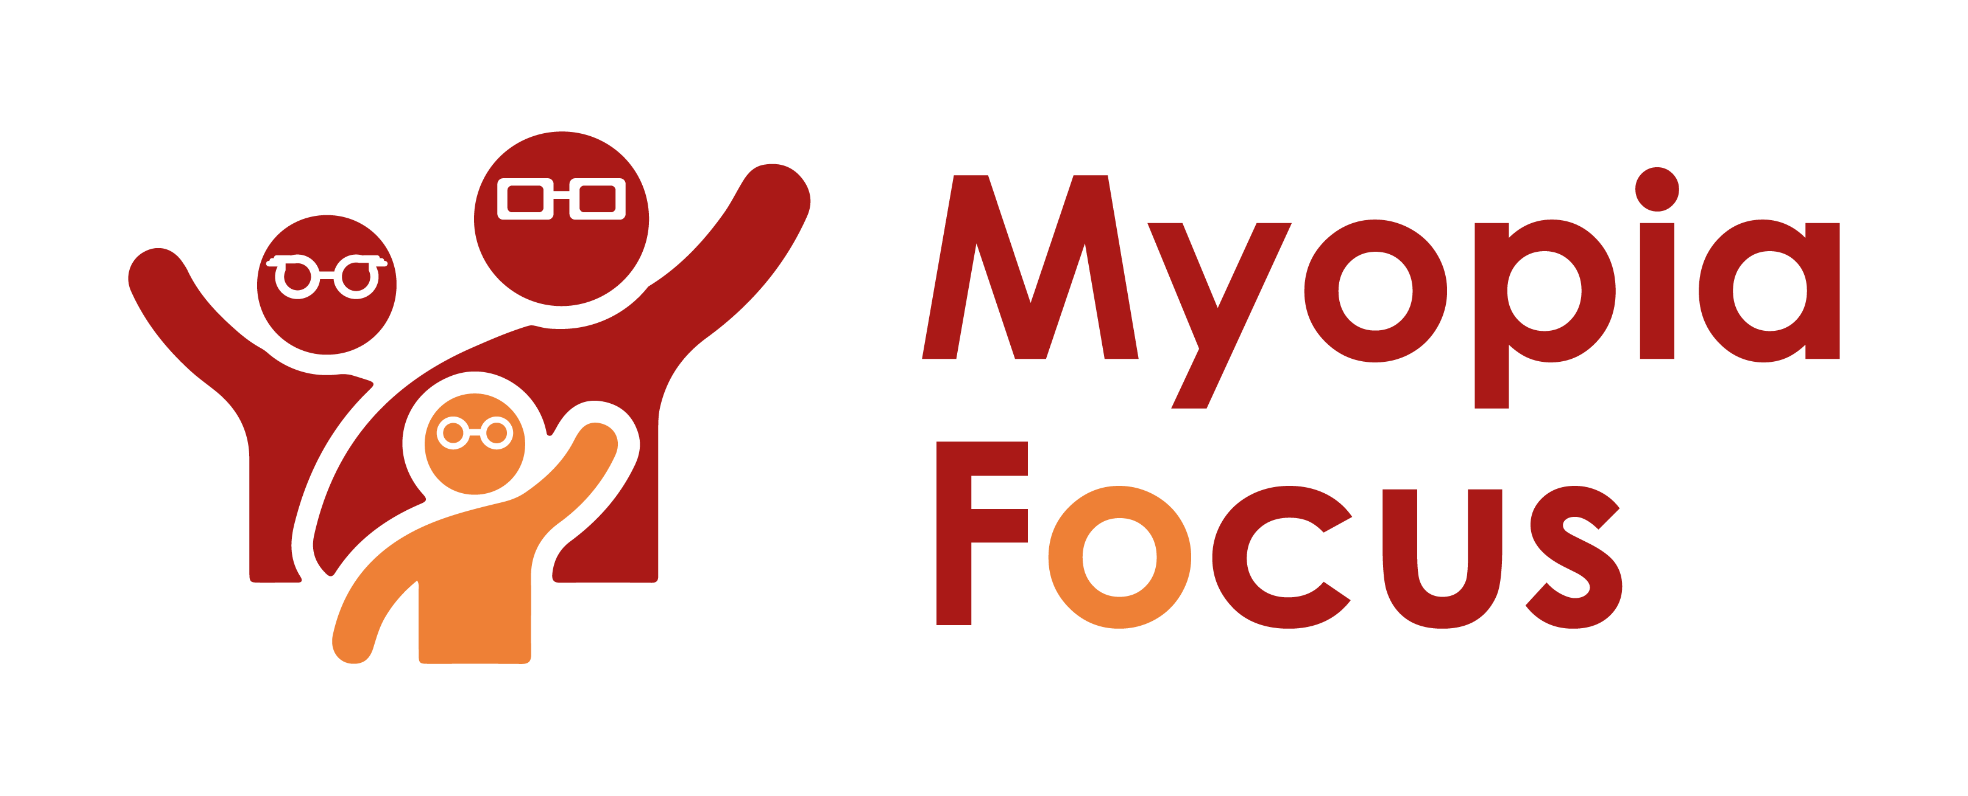
info@myopiafocus.org
0118 350 0800
www.myopiafocus.org
The Blade, Abbey Square,
Reading, RG1 3BE

Please note.
Thank you for downloading our article. Please feel free to add comments or make amendments to suit your needs before publishing it on your relevant platforms. However, as Myopia Focus is a non-profit organisation, we kindly request that you include a direct link to Myopia Focus within the article. This helps us spread awareness and ensure easy access to our resources. We appreciate your support and collaboration in promoting our mission.

The impact of myopia on eye health
Myopia, commonly known as near-sightedness, affects people of all ages, leading to various challenges. While misplacing glasses is a common issue for those diagnosed with myopia, there are more significant concerns for others, especially children with undiagnosed myopia.

Untreated myopia can hinder their academic performance, and sports activities, and even cause behavioural problems. Additionally, adults with uncorrected myopia may face challenges at work and encounter difficulties while driving. It's crucial to emphasize the importance of regular eye check-ups, as early diagnosis and management can prevent lifelong visual impairments. Moreover, myopia can increase the risk of other eye conditions, making vigilant monitoring essential.

The Impact of Myopia on Children:
Undiagnosed myopia in children can lead to academic struggles due to their inability to see the whiteboard or read text clearly. Sports activities may also become challenging, causing social isolation and behavioural issues. Eyestrain and headaches are common symptoms, sometimes leading to school absenteeism. Early detection and appropriate management are crucial to prevent worsening myopia and its adverse effects on a child's life.

The Impact of Myopia on Adults:
Uncorrected myopia can affect an adult's job performance, especially when tasks require clear distant vision. Moreover, driving with unaddressed eyesight problems can lead to legal consequences and potential accidents, particularly at night. Thus, regular eye tests and the use of corrective lenses are essential for maintaining visual clarity and safety.

Complications of Myopia:
Individuals with myopia, especially those with high myopia (refractive power of -6D or greater), are at an increased risk of developing various eye conditions. Retinal detachment is one such complication, characterized by a strain on the retina due to the elongated eyeball. This can lead to tears or detachment of the retina, causing symptoms like floaters, flashes of light, or shadows in the vision. Timely eye check-ups are vital to identify and address this condition promptly.
Myopic macular degeneration (MMD) is another concern, wherein ongoing myopia can lead to cell death in the centre of the retina or cracks in the underlying layers. This can cause a blind spot in the central vision, impacting reading and other activities. Regular eye examinations can aid in detecting MMD at an early stage.

Glaucoma, characterized by optic nerve damage, is more prevalent in individuals with high myopia. Early detection through routine eye check-ups is essential for effective glaucoma management, as it accounts for a significant portion of blindness cases.

Myopia is a prevalent issue worldwide, and early diagnosis is key to managing the condition effectively. For many, regular eye check-ups and the use of corrective lenses suffice. However, those with higher levels of myopia should be aware of potential complications, such as retinal detachment, myopic macular degeneration, and glaucoma. Timely detection through routine eye examinations can lead to better outcomes and prevent further complications. By raising awareness and prioritising eye health, we can mitigate the impact of myopia on individuals of all ages.

[Name of Business] is proud to support Myopia Focus

Independent information on myopia and myopia management can be found on myopiafocus.org.

Please also consider signing this change.org petition to get the NHS to recognise myopia as an ocular disease and improve funding for myopia management for children.

Images:
Please feel free to use the below image:

