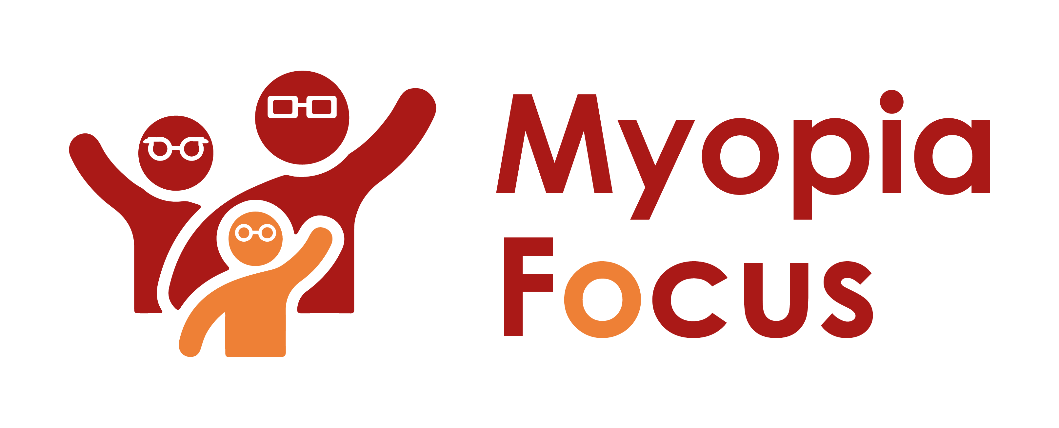
info@myopiafocus.org
0118 350 0800
www.myopiafocus.org
The Blade, Abbey Square,
Reading, RG1 3BE

Please note.
Thank you for downloading our article. Please feel free to add comments or make amendments to suit your needs before publishing it on your relevant platforms. However, as Myopia Focus is a non-profit organisation, we kindly request that you include a direct link to Myopia Focus within the article. This helps us spread awareness and ensure easy access to our resources. We appreciate your support and collaboration in promoting our mission.

5 Common Myths about Myopia

Myopia, also known as near-sightedness, is becoming increasingly prevalent worldwide, and according to the World Health Organization, it is projected that half of the global population will be affected by myopia by the year 2050. However, despite its widespread occurrence, several misconceptions about this condition persist. Let's explore and debunk some of the common myths associated with myopia.

Myth 1: Myopia only affects children, not adults
Myopia predominantly emerges during childhood. However, it is crucial to recognize that myopia can continue to develop and progress well into adulthood. Recent research findings have indicated that myopia may even increase in adults.
To ensure proactive eye care, it is highly recommended to schedule regular eye examinations for young children. These check-ups not only assess their vision but also monitor the overall health of their eyes. Early detection of myopia enables timely intervention and the exploration of myopia management treatments, which can effectively reduce the risk of developing high myopia later in life.
If your child has not undergone an eye test yet, we encourage you to make an appointment by clicking on the following link (insert link) for their visual health assessment.

Myth 2: Wearing contact lenses or glasses makes myopia worse
Wearing glasses or contact lenses does not lead to the worsening of one's prescription. The progression of myopia is primarily influenced by factors such as genetics, the amount of near work, prolonged indoor activities, and the extensive use of smartphones, among other variables.
Glasses and contact lenses play a crucial role in ensuring clear distance vision for individuals with myopia, preventing any blurry vision issues. To gain further insights into the most suitable solution for your specific needs, please reach out to us and we can discuss the next steps.
Myth 3: There is no way to slow down the progression of myopia
This is a prevalent myth. While some professionals believe that myopia can be reversed and cured, no clinical evidence supports this claim. However, scientific research has demonstrated that it is possible to significantly slow down the rate of myopia progression. Furthermore, as individuals age, the myopia levels off, and the final prescription may end up being much lower than initially predicted without any intervention. In other words, there are methods available to reduce the risk to your child's long-term eyesight.

Myth 4: Myopia will not cause blindness.
Myopia does not directly lead to blindness, but it can result in significant vision impairment and severe sight issues. In certain regions like South East Asia and Japan, long-term high myopia has been associated with an increased occurrence of various secondary eye conditions, including glaucoma, cataracts, and a particularly concerning condition known as Myopic Macular Degeneration (MMD). In fact, in certain areas of Japan, myopia has become the primary cause of new registrations for blindness.
Although myopia itself may not cause blindness, it should not be taken lightly. It requires serious attention, and there are proactive measures that can be taken to reduce the risk of vision loss in the future. Seeking professional advice from an eye specialist is essential to ensure appropriate management and care. Protecting your child's eyesight is of utmost importance, and early intervention can make a significant difference in safeguarding their vision in later life.

Myth 5: Contact Lenses are Dangerous for Children
Contrary to common belief, contact lenses are not inherently dangerous for children. In fact, recent studies have indicated that many younger children are diligent in following the correct protocols for maintaining their contact lenses, often surpassing the adherence of many adults. The key to ensuring safety lies in providing children with proper supervision and ensuring they regularly visit the eye care professional who prescribed the lenses for regular check-ups. When these precautions are taken, there should be no significant issues.
Moreover, contact lenses can be an excellent option for managing myopia in children. They have been clinically proven to be effective, offering clear vision and granting children more freedom to engage in outdoor activities and sports. By choosing contact lenses as a viable solution for myopia management, children can enjoy improved vision and an active lifestyle.

[Name of Business] is proud to support Myopia Focus

Independent information on myopia and myopia management can be found on myopiafocus.org.

Please also consider signing this change.org petition to get the NHS to recognise myopia as an ocular disease and improve funding for myopia management for children.

Images:
Please feel free to use the below image:

