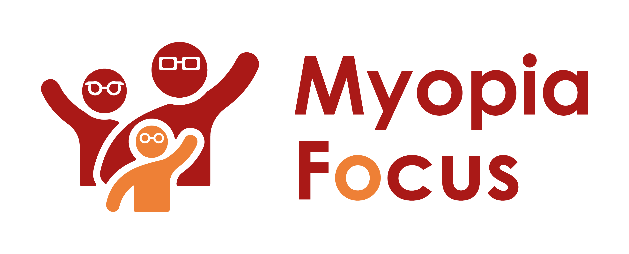
info@myopiafocus.org
0118 350 0800
www.myopiafocus.org
The Blade, Abbey Square,
Reading, RG1 3BE

Please note.
Thank you for downloading our article. Please feel free to add comments or make amendments to suit your needs before publishing it on your relevant platforms. However, as Myopia Focus is a non-profit organisation, we kindly request that you include a direct link to Myopia Focus within the article. This helps us spread awareness and ensure easy access to our resources. We appreciate your support and collaboration in promoting our mission.

Is it possible for myopia to improve?

Addressing myopia, also known as short-sightedness, after its diagnosis often raises the question of potential remedies to improve eyesight. While reversing existing myopia may be challenging, there are steps individuals can take to influence its future development.
One crucial step is ensuring the correct prescription for glasses or contact lenses. Wearing under-strength lenses or forgoing corrective lenses altogether can accelerate eyeball growth, leading to increased myopia. On the other hand, using lenses that match the current level of myopia can help reduce blur and maintain clear vision.

Therapeutic interventions offer the potential to slow down myopia progression. These interventions may involve wearing myopia control lenses or adjusting lifestyle factors, such as reducing close work, especially on computers, and increasing outdoor time.

Myopia control lenses not only correct distance vision but also alter how light reaches the retina's periphery or lessen the effort required for close work. This can reduce the triggers that lead to excessive eyeball growth and higher levels of myopia.

Such interventions are particularly valuable for children, as myopia tends to appear during early childhood and progresses with age. While the prescription may stabilize at some point, studies suggest that myopia can continue to progress into adulthood. Therefore, therapies that slow down myopia's progression in childhood could result in lower prescription requirements throughout an individual's life.

Additionally, addressing myopia early in children may help reduce the risk of developing other eye conditions, such as cataracts, glaucoma, or detached retinas, later in life. Hence, taking action as soon as childhood myopia is identified can positively impact an individual's long-term eye health.

[Name of Business] is proud to support Myopia Focus

Independent information on myopia and myopia management can be found on myopiafocus.org.

Please also consider signing this change.org petition to get the NHS to recognise myopia as an ocular disease and improve funding for myopia management for children.

Images:
Please feel free to use the below image:

