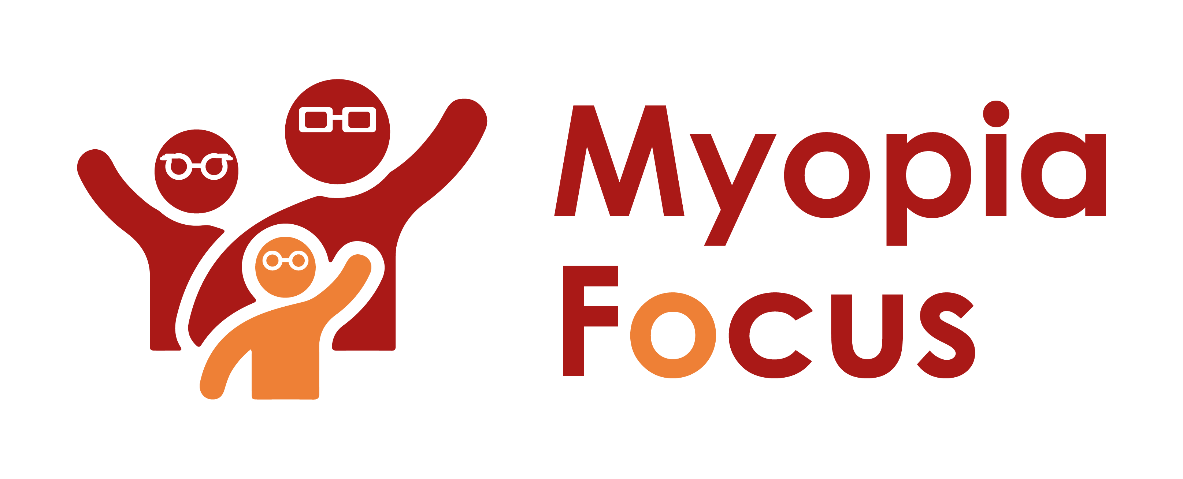
info@myopiafocus.org
0118 350 0800
www.myopiafocus.org
The Blade, Abbey Square,
Reading, RG1 3BE

Please note.
Thank you for downloading our article. Please feel free to add comments or make amendments to suit your needs before publishing it on your relevant platforms. However, as Myopia Focus is a non-profit organisation, we kindly request that you include a direct link to Myopia Focus within the article. This helps us spread awareness and ensure easy access to our resources. We appreciate your support and collaboration in promoting our mission.

Myopia vs. Short-Sightedness: Understanding the Difference

Myopia and short-sightedness are indeed the same condition. When an optician checks your child's eyes, they might use both terms interchangeably. Essentially, being short-sighted means that you can focus on objects close to you, but distant objects appear blurry. This occurs when the eye's development causes light to be focused in front of the retina rather than on it.

The degree of short-sightedness is determined by how far you can see before objects become blurry. For instance, someone with mild short-sightedness might be able to read a book held 40cm away from their eyes, while someone with more severe short-sightedness would need to bring the book closer to see it clearly.

In prescriptions for short-sightedness, corrective lenses are denoted by minus figures. For example, a prescription might be -2.5 for the person with mild short-sightedness, while someone who needs to hold a book just 10cm from their eyes might require a prescription of -10. Glasses or contact lenses can generally correct short-sightedness, and early identification in children allows for interventions to potentially slow its progression through suitable prescriptions and lifestyle adjustments.

In cases of high myopia, particularly in older individuals with long-term myopia, it can lead to complications that may cause permanent damage to the eyes. Although glasses can bring light into focus on the retina, severe damage to the eyes may result in very poor vision [1].

Apart from myopia, there's another term you might come across related to short-sightedness called "astigmatism." Astigmatism occurs when the cornea, the front surface of the eye, is more curved along one axis and less curved along the axis at 90 degrees, leading to scattered light inside the eye. Many people have astigmatism, and it often coexists with myopia, where the eye is more myopic in one direction compared to the 90-degree direction. Therefore, your spectacle prescription may include information about Sphere, Cylinder, and Axis to address astigmatism.

[Name of Business] is proud to support Myopia Focus

Independent information on myopia and myopia management can be found on myopiafocus.org.

Please also consider signing this change.org petition to get the NHS to recognise myopia as an ocular disease and improve funding for myopia management for children.

Images:
Please feel free to use the below image:

