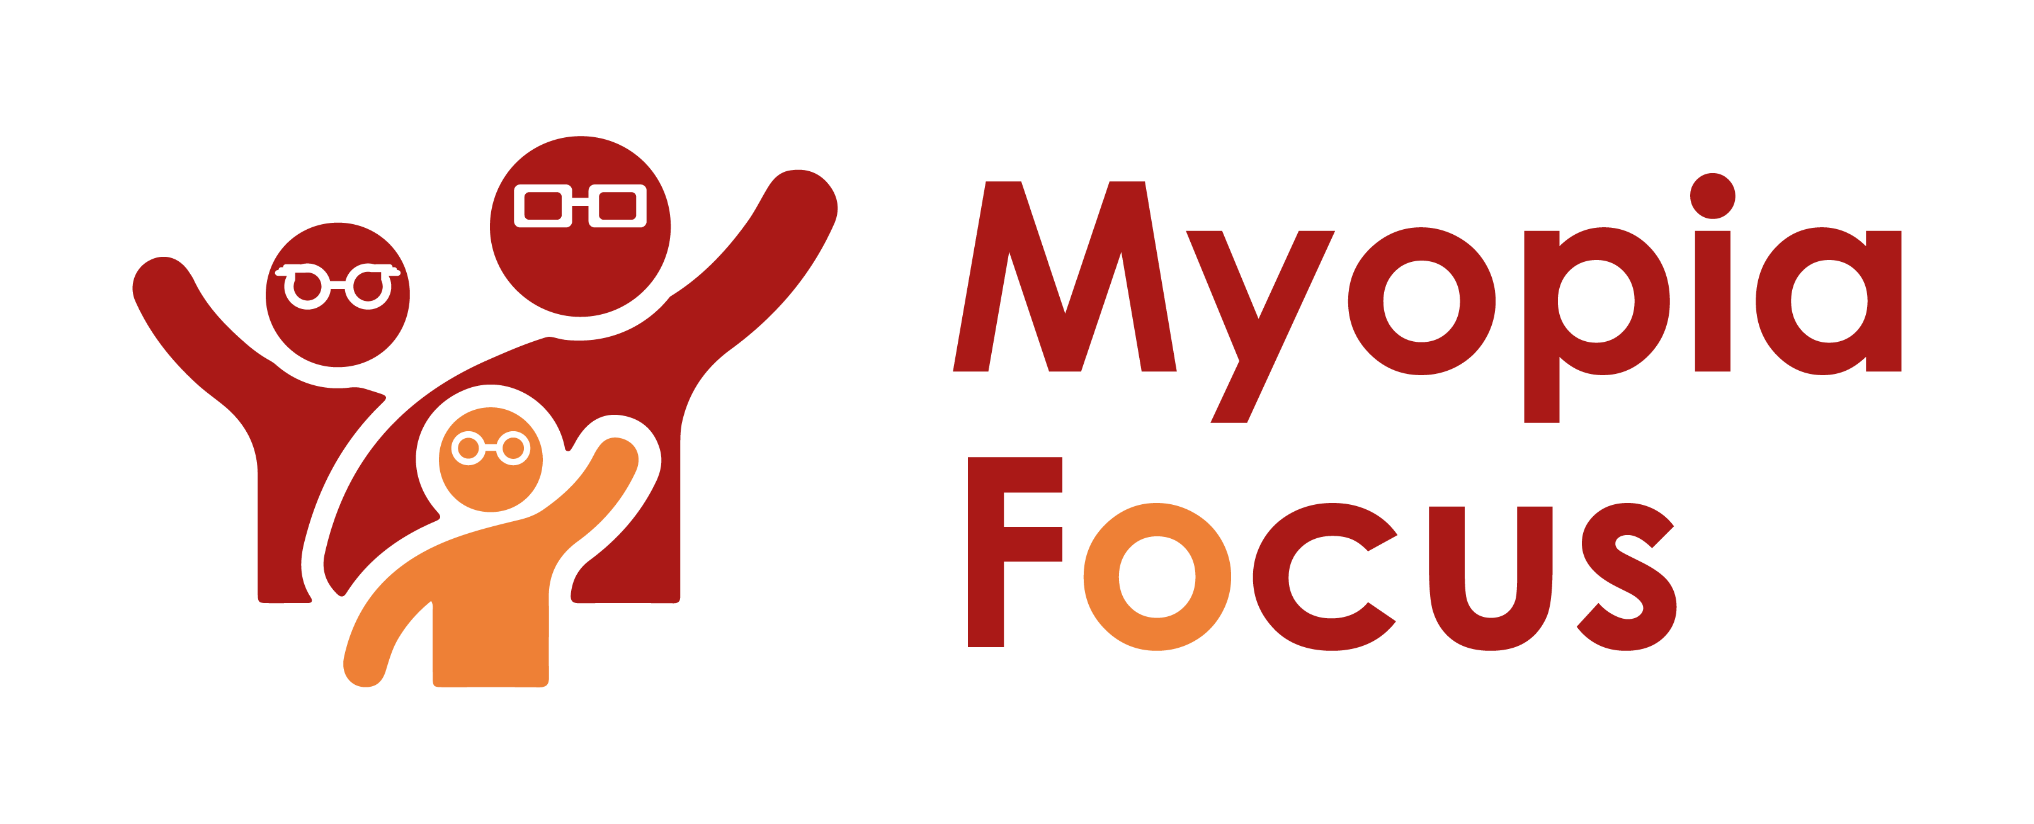
info@myopiafocus.org
0118 350 0800
www.myopiafocus.org
The Blade, Abbey Square,
Reading, RG1 3BE

Please note.
Thank you for downloading our article. Please feel free to add comments or make amendments to suit your needs before publishing it on your relevant platforms. However, as Myopia Focus is a non-profit organisation, we kindly request that you include a direct link to Myopia Focus within the article. This helps us spread awareness and ensure easy access to our resources. We appreciate your support and collaboration in promoting our mission.

How Visual Impairment Affects Children's Mental Health

In ancient Roman times, the poet Juvenal coined the phrase "a healthy mind in a healthy body," emphasizing the connection between mental and physical well-being. Despite this understanding, when faced with a physical health challenge, it's common to focus solely on the physical aspect of healing, overlooking the potential impact on mental health.

The interlink between physical and mental health is especially crucial to consider in the context of visual impairment. A study presented in 2018 revealed that children aged eight to eleven with visual impairment were three times more likely to develop mental health problems [1]. Dr. Naomi Dale, a Consultant Clinical Psychologist, highlighted that visual impairment poses significant challenges to learning, development, and mental health from early childhood [2].

Another review in 2016 underscored the link between sight impairment and a child's psychological well-being, indicating that between 20% and 30% of visually impaired children may require professional advice and support [3].

While some studies primarily focus on children with severe visual impairment, it is evident that visual and mental health issues could be closely related. Even before identifying the need for corrective lenses, the deterioration of a child's eyesight could already be negatively affecting their mental well-being. Struggling to see the whiteboard in school or feeling clumsy in sports may lead to feelings of isolation and self-doubt, creating a negative spiral.

Providing corrective lenses may be sufficient for some children, but we should acknowledge the potential impact that wearing glasses can have on their self-perception. A Chinese study revealed that while wearing glasses reduced physical and learning anxiety in high-intensity studying students, less academically inclined students reported higher levels of learning anxiety when wearing glasses [4]. Teasing of glasses wearers may contribute to this disparity, a concern that parents and teachers should be aware of.

For children uncomfortable with glasses, corrective contact lenses may offer a solution. However, it is crucial not to neglect the issue, as untreated visual impairment is likely to worsen, increasing anxiety levels and creating long-lasting problems into adulthood.

[Name of Business] is proud to support Myopia Focus

Independent information on myopia and myopia management can be found on myopiafocus.org.

Please also consider signing this change.org petition to get the NHS to recognise myopia as an ocular disease and improve funding for myopia management for children.

Images:
Please feel free to use the below image:
