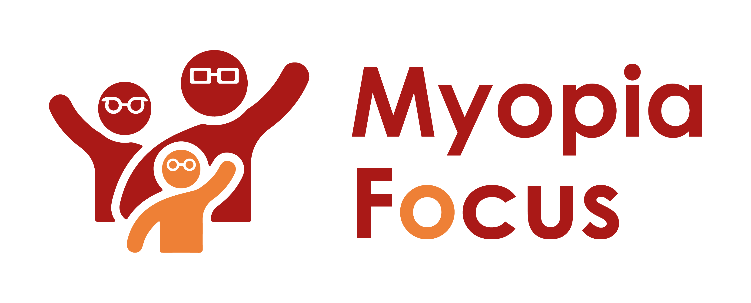
info@myopiafocus.org
0118 350 0800
www.myopiafocus.org
The Blade, Abbey Square,
Reading, RG1 3BE

Please note.
Thank you for downloading our article. Please feel free to add comments or make amendments to suit your needs before publishing it on your relevant platforms. However, as Myopia Focus is a non-profit organisation, we kindly request that you include a direct link to Myopia Focus within the article. This helps us spread awareness and ensure easy access to our resources. We appreciate your support and collaboration in promoting our mission.

Safety of Contact Lenses for Children
Why don't rugby or football players wear glasses during games? The answer, which applies to other contact sports as well, is that players who require eyesight correction often opt for contact lenses while participating in sports.
Considering the risks involved, it's clear why contact lenses are the preferred choice. Glasses can easily become dislodged or broken during intense physical activity, potentially causing harm to the wearer or others. On the other hand, contact lenses offer a safer alternative, ensuring excellent visual perception of the playing area.
This leads to the question of whether children can safely wear contact lenses to fully engage in sports and other activities. Opticians frequently encounter this query, especially when dealing with children diagnosed with myopia. Fortunately, the answer is affirmative; children can generally wear contact lenses safely. A study from 2017 revealed that children face no higher risk from wearing contact lenses than adults, and in some cases, the risk might even be lower, particularly among 8-11-year-olds [1].
These findings have been corroborated by various other reviews, indicating that wearing contact lenses for an extended period does not adversely affect eye health. As a result, children can begin wearing contact lenses at a relatively young age. Some opticians and researchers suggest starting at eight years old, but considering the earlier onset of myopia, corrective contact lenses could be employed in even younger children.
According to an advice leaflet from Cambridge University Hospitals NHS Foundation Trust, children as young as two days old have safely used contact lenses in specific cases [2]. The choice of lenses will depend on the child's condition and age, with younger children possibly requiring specialist lenses that can be worn for more extended periods.
While contact lenses are generally safe for children, there are some important considerations. Firstly, lenses should not be worn while swimming, in which case corrective swim goggles are recommended. Additionally, maintaining good hand hygiene is essential to avoid any potential issues arising from handling contact lenses.
Furthermore, Ortho-K, a special type of contact lens known as NIGHT LENSES, is worn during sleep and helps reshape the cornea. This allows for clear vision during the day, enabling children to participate more confidently in sports. Studies have shown that children feel much more self-assured when they don't need to wear glasses or contact lenses during the day, leading to increased outdoor time and contributing to their overall health and happiness. Moreover, Ortho-K lenses can also help slow the progression of myopia, making them a highly beneficial option.
[Name of Business] is proud to support Myopia Focus

Independent information on myopia and myopia management can be found on myopiafocus.org.

Please also consider signing this change.org petition to get the NHS to recognise myopia as an ocular disease and improve funding for myopia management for children.

Images:
Please feel free to use the below image:
